**CRSPE/IEEE**

*Canton Regional Society of Professional Engineers*

*Institute of Electrical and Electronic Engineers*

**Monday, April 30, 2012**

356th Fighter Group Restaurant

4919 Mt. Pleasant Rd., N. Canton, OH 44720

**Energy Savings Opportunities**

**Matt Brakey, President, Brakey Energy**

**Steve Metheny, President, Metheny Inc.**

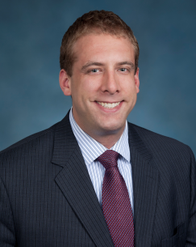

C:\Users\Rick\AppData\Local\Microsoft\Windows\Temporary Internet Files\Content.IE5\7VRQIFAN\MC900353999[1].wmf5:30 – Cash Bar

6:15 – Dinner

7:00 – Program

Matt Brakey

**Cost: $25 per person**

**IEEE: Members - $20/Students $15**

Choice of:

Vegetable Stir Fry

Potato Encrusted Scrod

Chicken Marsala

Please contact Rick Buchanan at (330) 497-8250 or [RLBuchanan@att.net](mailto:RLBuchanan@att.net) for reservations no later than Friday, April 27. Please include your meal choice with your reservation.

**1 CPD Hour**